！！TensorFlow 中 RNN&LSTM 的使用https://blog.csdn.net/mzpmzk/article/details/80573338

{
RNN基类：class tf.contrib.rnn.BasicRNNCell(num_units, activation=None, reuse=None, name=None)
LSTM基类：class tf.contrib.rnn.BasicLSTMCell(num_units, forget_bias=1.0, state_is_tuple=True, activation=None, reuse=None, name=None)
tf.nn.dynamic_rnn：(cell, inputs, initial_state=None, sequence_length=None, dtype=None, parallel_iterations=None, swap_memory=False, time_major=False, scope=None)
一次执行多步，解决基础的 RNNCell 每次只能在时间上前进了一步的缺点。使用该函数就相当于调用了 n 次call函数。即通过(h0,x1,x2,….,xn)(h0,x1,x2,….,xn) 直接得 (h1,h2…,hn)(h1,h2…,hn)。

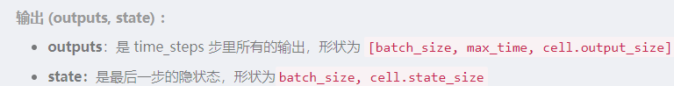
ＢＬＳＴＭ：tf.nn.bidirectional_dynamic_rnn(cell_fw,cell_bw,inputs, initial_state_fw=None, initial_state_bw=None,sequence_length=None,dtype=None,parallel_iterations=None,swap_memory=False, time_major=False, scope=None)
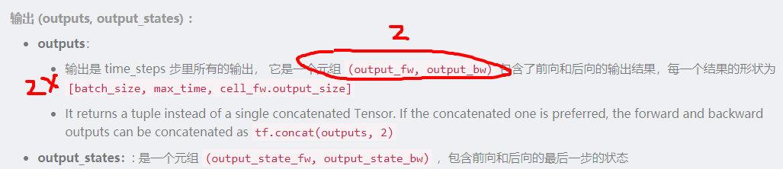

堆叠多层：MultiRNNCell
单层 RNN 的能力有限，我们需要多层的 RNN，在 TensorFlow 中，可以使用 tf.nn.rnn_cell.MultiRNNCell 函数对RNNCell 进行堆叠。

}

动态-静态 对比 （单层）
https://www.jianshu.com/p/1b1ea45fab47

##========================================================================
TensorFlow RNN 一些技巧：
- RNN 初始化
- 优化RNN
- dropout功能
- LN基于层的归一化

static_rnn-------bidirectional_dynamic_rnn()

输入输出对比：
https://blog.csdn.net/qq_35203425/article/details/81332807
https://blog.csdn.net/cerisier/article/details/80135999
https://blog.csdn.net/cerisier/article/details/80135999
https://blog.csdn.net/zhylhy520/article/details/86364789
LSTM，BiLSTM结构详述：
https://blog.csdn.net/fendouaini/article/details/80198994
实例：
https://github.com/jiangxinyang227/textClassifier/blob/master/Bi-LSTM%2BAttention/Bi-LSTMAttention.ipynb

输入
Static_RNN:List (tensor.....tensor)
Bi_RNN:(batch*N*cellnum)
输出：
Rnn;List(Batch*cellnum)
Birnn 2* max*batch*cellnum--》2：{fw,bw}

bidirectional_dynamic_rnn()--------tf.nn.static_bidirectional_rnn
https://blog.csdn.net/weixin_44624453/article/details/86678980

